***Media Alert****
98.5 KLUC’s Chet Buchanan & The Morning Zoo Toy Drive
KICK’S OFF TOMORROW MORNING!!
Feel the Tingle This Holiday Season and Donate…
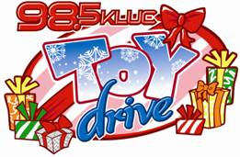
- 24 Hours A Day - 12 Straight Days - 13 ^{th} Straight Year
- Thursday, December 1st - Monday, December 12th
- Be there at 6AM to watch the event unfold & 8AM when Chet is lifted up onto the scaffolding where he will live for the next 12 days to raise money and toy donations for kids with HELP of Southern Nevada!
- Contact KLUC for interview opportunities with Chet on-site

Stacie Schmidt
Director of Marketing, CBS Radio Las Vegas
KMXB-FM, KXTE-FM, KLUC-FM, KYDZ-AM, KXNT-FM/AM
7255 S Tenaya Way Suite 100
Las Vegas, NV 89113
702-889-7517 Direct
702-889-7555 Fax
Stacie.Schmidt@CBSRadio.com

NOTICE: The entirety of this email message and all attachments may contain information that is legally privileged, confidential or exempt from disclosure. If you are not the intended recipient, please note that any dissemination, distribution, or copying of this communication is prohibited. If you have received this message in error, please notify the sender immediately by telephone or by return email, and delete this communication and all attachments from your computer or PDA.

